Sensors:

Sensors are an important part of any robot; they can retrieve information that is easily accessible to us humans. Temperature, distance, oxygen levels to name a few are converted into an electrical reading that can be processed by the brains of the robot. Furthermore, they can be used as a way to give important parameters to a robot in order to function properly. Below you will find a few sensors that could be used to further enhance our project idea.

**LIDAR sensor**

Light Detection and Ranging is a very interesting remote sensor that measures the exact distance of an object. The LIDAR sensor uses a pulsing technique where it pulses light to determine the exact location of whatever the sensor is aimed at. Since the LIDAR technology uses light, we can calculate the distance by the following formula:

$$D=\frac{C*T}{2}$$

Where “D” is the distance of the object, C is the speed of light (299,792,458 m/s) and T is the time it takes to return to the LIDAR source.

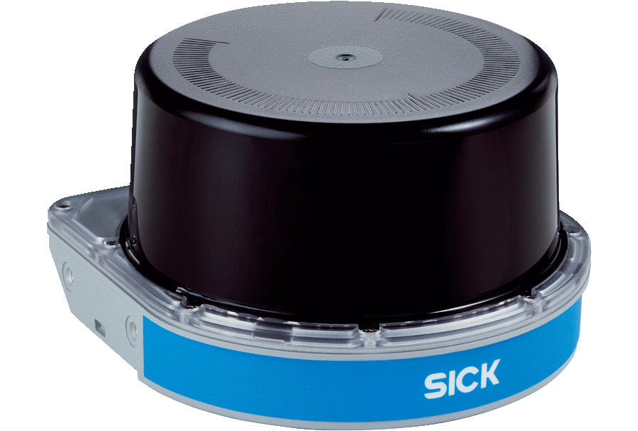

Figure 1 Showcasing a LIDAR sensor

[**https://www.geospatialworld.net/blogs/what-is-lidar-technology-and-how-does-it-work/**](https://www.geospatialworld.net/blogs/what-is-lidar-technology-and-how-does-it-work/)

**Ultrasonic sensor**

Ultrasonic sensor is a very interesting sensor that shoots ultrasonic waves to calculate the distance. Much like the LIDAR sensor, it waits for the waves to return back and from there we can calculate the distance. Furthermore, it uses a transducer to send and receive high frequency pulses to determine the location. The equation below is used with the specific model HC-SR04

$$D=\frac{S*T}{2}$$

Where D is the distance, S is the speed of sound (340m/s) and T is the time.

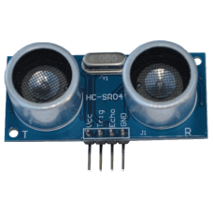

Figure 2 Showcasing an Ultrasonic Sensor

[**https://www.maxbotix.com/articles/how-ultrasonic-sensors-work.htm**](https://www.maxbotix.com/articles/how-ultrasonic-sensors-work.htm)

**IR sensor**

These sensors work by emitting and receiving infrared radiation. The radiation hits objects nearby while the receiver waits for the bounce-back of the signal. It can detect movement and distance of the object. There are three types of infrared ranges;

* Near-infrared - from 0.75 to 3 3µm
* Mid-infrared - from 3 to 6µm
* Far-infrared - higher than 6µm

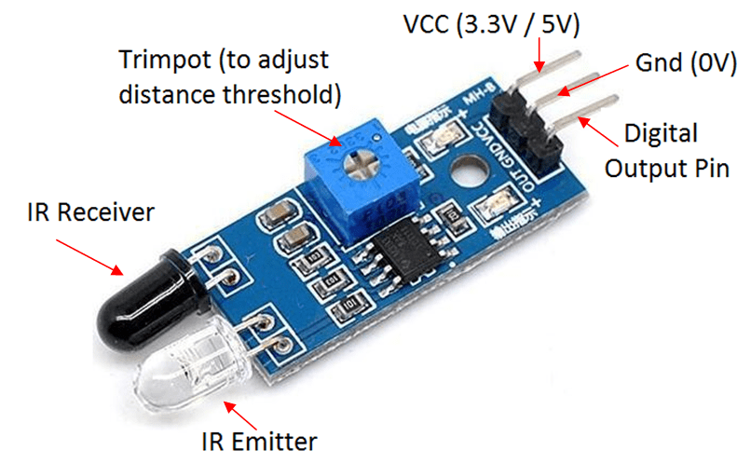

Figure 3 Showcasing the IR sensor

https://www.getkisi.com/guides/infrared-sensors